Full Paper Submission
Péter Kovács –Miklós Lukovics

This paper contains the formal requirements of the full papers.

Keywords: please write 3-5 words

Introduction
Papers should be submitted as an electronic file, preferably .doc. Papers should be written in English and should not be longer than 20 pages with 1 spacing (Times New Roman, size: 11), including figures, tables, and references. Please use this format. The figures and tables are to be referred to in the text by number, not by page or indication such as “below” or “above”.
The list at the end should correspond to those in the text; they should be arranged alphabetically, and for the same author chronologically. References in text should be indicated in either of the two ways used in the following examples (Maskell et. al. 1998) or (Maskell 1998)

Format Guidelines
Tables and figures should be numbered and references to them must be in the text. Acceptable labeling is Table 1 for a table and Figure 1 for a figure. The title of the table or figure is placed above and the source is referenced below the table or figure. The text should be composed in such a manner that the page containing the reference precedes the referenced figure or Tables and figures in portrait format are not acceptable.

Table 1: Title of the Table (Times New Roman, 11, centered)
 | 1998 | 1999 | 2000 | 2001 | 2002
Poland
Russia
Sweden
Source: please provide a source website, paper, author’s calculations, etc.

Figure 1: US Dollar to Swedish Krona Exchange Rate
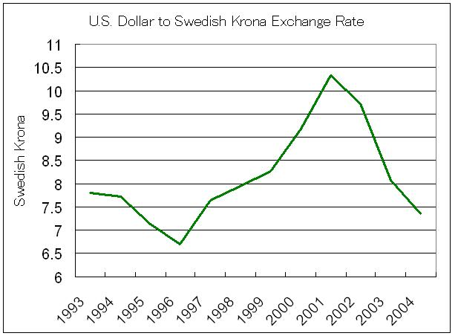
Source: National Bank of Sweden

Equations and formulas are denoted by numbers in round parentheses and it is recommended to be produced by Microsoft Equation Editor or inserted in jpeg format.

$\underset{λ}{\text{min}}z_{0}=Θ_{0}$ (1)
$\sum_{j=1}^{n}{λ_{j}y_{r_{j}}}y_{r_{0}},r=1,2,\text{.}\text{.}\text{.},s$ (2)
$Θ_{0}x_{i_{0}}−\sum_{j=1}^{n}{λ_{j}x_{i_{j}}}0,i=1,2,\text{.}\text{.}\text{.},n$ (3)
$\sum_{j=1}^{n}{λ_{j}}=1$ (4)
λ_{j} ≥ 0, j = 1,2,…,n (5)

Steps of the process
In this part you can find the steps of the
- Format your paper according to our requirements and send it to conference@eco.u-szeged.hu. The deadline of full paper submission is 20.01.2012.
- We will send your paper to the reviewers.
- If the reviewers send us a positive review, your paper will be published.
Bibliographic citation must be in accordance to examples provided below. The list of references should be complete and accurate. For each work shown in the list of references must be a reference in the text. Citation in the text must be according to following rules:
- 1 author
  - Stavárek (2004) has argued that...
  - ...This was seen in a Czech study (Stavárek, 2004).
- 2 authors
  - ... should be considerably improved (McCarty and Yaisawarng, 1993).
  - McCarty and Yaisawarng (1993) suggest application of …
- 3 and more authors: cite only the first name followed by et al.
  - ... should be considerably improved (Brown et al., 1990).
  - Brown et al. (1990) suggest application of …
References
Use the provided citation style for references
Make the list of references in alphabetical order
The list of references must contain only items cited in the text
The articles of references which are not in English must be translated, for example:
Molnár, M. B. 2006: A hatékony piacokról szóló elmélet kritikái és empírikus tesztjei (The critics and empirical tests of efficient market theory). Hitelintézeti Szemle, 5, 3, 44-62

Citation of a book
Maskell, P. – Eskelinen, H. – Hannibalsson, I. – Malmberg, A. – Vatne, E. 1998: Competitiveness, Locational Learnings and Regional Development: Specialisation and prosperity in small open economies. Routledge, London.
Porter, M. E. 1990a: The Competitive Advantage of Nations. Free Press, New York.
Porter, M. E. 1990b: Location and Regional Clusters. Belhaven, London.

Citation of a book chapter
Mytelka, L. K. 1999: Competition, Innovation and Competitiveness: A Framework for Analysis. In Enright, P. (ed.): Competition, Innovation and Competitiveness in Developing Countries. OECD, Paris, 15-32
Waits, M. J. 1998: Economic Development Strategies in the American States. In Liou, K. T. - Maskell, K. (eds.): Handbook of Economic Development. Marcel Dekker, New York, 183-214. o.

Citation of a journal paper
Feser, E. J. 1998: Enterprises, external economies, and economic development. Journal of Planning Literature, 12, 3, 283-302
Gordon, I. R. – McCann, P. 2000: Industrial Clusters: Complexes, Agglomeration and/or Social Netorks? Urban Studies, 37, 3, 513-532

Péter Kovács, PhD, senior lecturer, University of Szeged, Faculty of Economics and Business Administration, Hungary.
Miklós Lukovics, PhD, senior lecturer, University of Szeged, Faculty of Economics and Business Administration, Hungary. Acknowledgement:

